Portkey AI Cost Allocation and Estimate — Guide
Oct 21, 2026 · @Alfred Daluyaya
AWS is the source of truth for cost. Portkey gives the allocation percentage. Shared cost is a load on each dollar of inference.
Use this guide to build the Word document. Each section is one page in the Word document:
- Use case: how AI requests flow through Portkey to AWS.
- Terms: direct cost and shared cost.
- Allocation: Portkey gives each workspace its percentage of the direct cost.
- Example: the chargeback for three workspaces.
- Estimate: the load rate for future cost.
Section 6 is a decision for the team: one bucket or two for DEV and PROD.
All numbers in this guide are examples. They are not PG&E data. All sections use the same example month, so the numbers agree from page to page.

1. The use case: how AI requests flow
Every AI request goes through Portkey before it reaches a model in AWS. Users, AI apps and tools such as Claude Code send their requests to a Portkey workspace. The Portkey gateway then sends each request to a model in Amazon Bedrock.
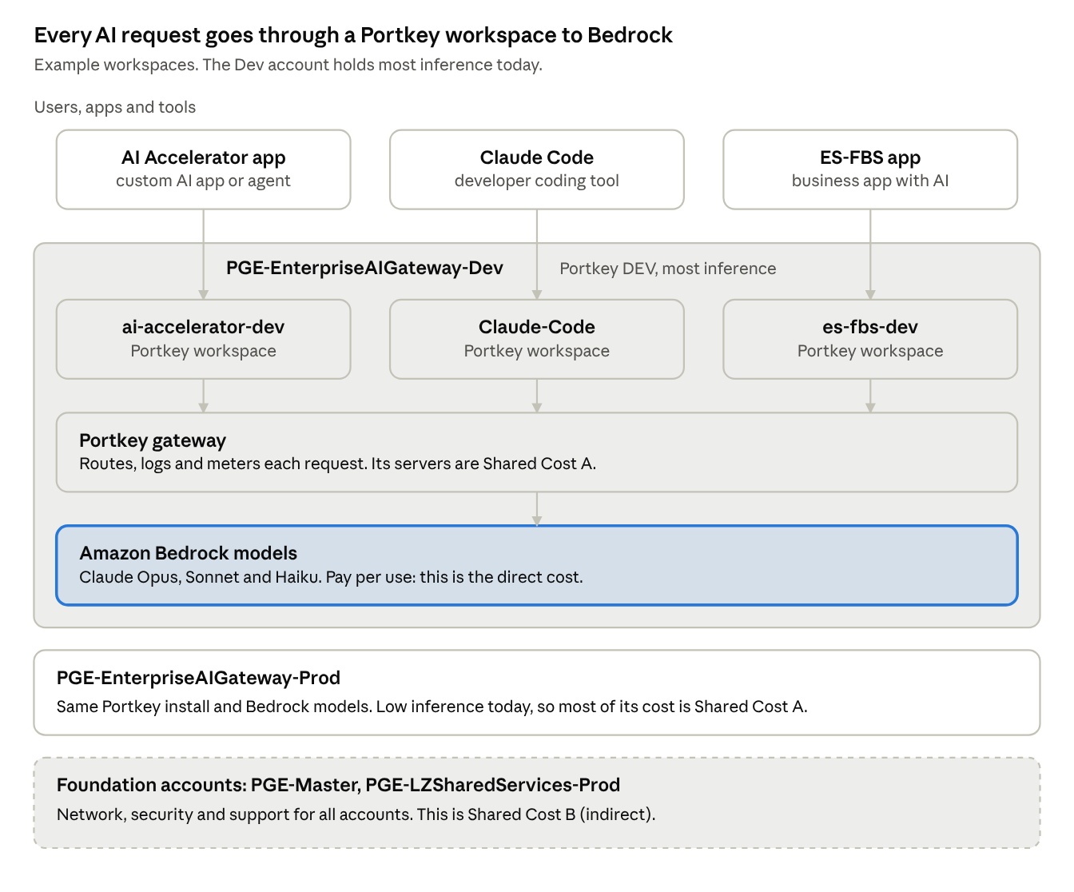
AI request flow · 3 callers, 3 workspaces, 4 AWS accounts
AWS account | What it holds | Cost part
PGE-EnterpriseAIGateway-Dev | Portkey install (DEV) and Bedrock models. Most inference is here today. | Direct cost and Shared Cost A
PGE-EnterpriseAIGateway-Prod | Portkey install (PROD) and Bedrock models. Inference is low today. | Direct cost and Shared Cost A
PGE-Master | Base services that support all accounts. | Shared Cost B (to confirm)
PGE-LZSharedServices-Prod | Landing zone shared services for all accounts. | Shared Cost B (to confirm)
Three facts make the rest of this guide work:
- A workspace is the entry point. Each app or tool sends its requests to its own workspace, for example ai-accelerator-dev, Claude-Code or es-fbs-dev.
- Portkey logs each request with its workspace, model and cost.
- AWS bills the account, not the workspace. AWS cannot show which workspace used a model. Section 3 shows how Portkey fills this gap.

2. Terms: direct cost and shared cost
The total AI cost has three parts: one direct cost and two shared costs. The three parts must add up to the billed amount. Nothing is added on top.
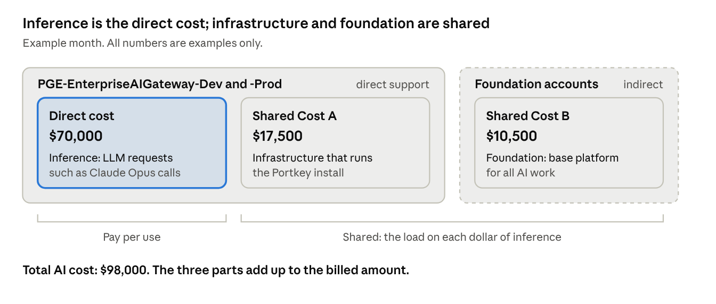
AI cost for one example month · 1 direct cost, 2 shared costs, 2 AWS accounts
Term | What it is | Where it comes from | How it is charged
Direct cost (inference) | The cost to run the LLM requests, such as Claude Opus calls on Amazon Bedrock. | PGE-EnterpriseAIGateway-Dev and -Prod | Pay per use. Each workspace pays for its own requests.
Shared Cost A (infrastructure) | The cost to run the Portkey install, such as compute, network, logs and storage. | PGE-EnterpriseAIGateway-Dev and -Prod | Shared. Each workspace pays a part, in proportion to its direct cost.
Shared Cost B (foundation) | The cost of the base platform that supports all AI work. It is not in the gateway accounts. | PGE-Master, PGE-LZSharedServices-Prod | Shared. Each workspace pays a part, in proportion to its direct cost.
The direct cost changes with use. If a workspace sends no requests, its direct cost is zero.
The shared cost does not change with each request. PG&E must pay it to keep the AI platform available. Think of the shared cost as a tax on each dollar of inference. Shared Cost A is a direct tax. Shared Cost B is an indirect tax.

Example: the bill for one month
The table shows the AWS Cost Explorer lines for each part. The service names are the names that Cost Explorer shows. The amounts are placeholders. Replace them with the real lines from the gateway accounts and the foundation accounts.
Part | Cost Explorer service | AWS account | Example amount (USD/month)
Direct cost | Claude Opus 5.5 (Amazon Bedrock Edition) | PGE-EnterpriseAIGateway-Dev | 38,000
Direct cost | Claude Sonnet 5.5 (Amazon Bedrock Edition) | PGE-EnterpriseAIGateway-Dev | 23,000
Direct cost | Claude Haiku 5.5 (Amazon Bedrock Edition) | PGE-EnterpriseAIGateway-Dev | 5,000
Direct cost | Amazon Bedrock (Amazon models, such as embeddings) | PGE-EnterpriseAIGateway-Dev | 3,000
Direct cost | Claude Sonnet 5.5 (Amazon Bedrock Edition) | PGE-EnterpriseAIGateway-Prod | 1,000
Direct cost total |  |  | 70,000
Shared Cost A | Amazon Elastic Compute Cloud - Compute (gateway nodes) | PGE-EnterpriseAIGateway-Dev | 5,000
Shared Cost A | EC2 - Other (NAT gateway, EBS volumes, data transfer) | PGE-EnterpriseAIGateway-Dev | 2,500
Shared Cost A | Amazon ElastiCache (gateway cache) | PGE-EnterpriseAIGateway-Dev | 1,500
Shared Cost A | AmazonCloudWatch (logs and metrics) | PGE-EnterpriseAIGateway-Dev | 1,500
Shared Cost A | Amazon Elastic Load Balancing | PGE-EnterpriseAIGateway-Dev | 1,000
Shared Cost A | Amazon Simple Storage Service (log export) | PGE-EnterpriseAIGateway-Dev | 1,000
Shared Cost A | Amazon Elastic Container Service for Kubernetes | PGE-EnterpriseAIGateway-Dev | 500
Shared Cost A | AWS Secrets Manager, AWS Key Management Service | PGE-EnterpriseAIGateway-Dev | 500
Shared Cost A | Gateway infrastructure (the same services as DEV) | PGE-EnterpriseAIGateway-Prod | 4,000
Shared Cost A total |  |  | 17,500
Shared Cost B | AWS Support (Enterprise) | PGE-Master | 4,500
Shared Cost B | Amazon GuardDuty, AWS Security Hub, AWS Config | PGE-Master | 3,000
Shared Cost B | AWS CloudTrail | PGE-Master | 1,000
Shared Cost B | AWS Transit Gateway, AWS Direct Connect | PGE-LZSharedServices-Prod | 2,000
Shared Cost B total |  |  | 10,500
The Shared Cost B amounts are only the part of each foundation account line that is assigned to AI. They are not the full line.
How to find the direct cost in Cost Explorer:
- AWS bills the Claude models through AWS Marketplace. Each Claude model is a separate service, and its name ends with "(Amazon Bedrock Edition)". source
- A filter on the service "Amazon Bedrock" shows only the Amazon models. It does not show Claude. source
- To get all of the direct cost, include each "(Amazon Bedrock Edition)" service and the "Amazon Bedrock" service.
- Since October 8, 2026, Cost Explorer can also group Bedrock cost by model attributes. Use this to check the model totals. source

3. Allocation: Portkey gives the percentage
AWS is the source of truth for cost, because AWS sends the invoice. Portkey is the source of truth for use, because each LLM request goes through a Portkey workspace.
AWS does not show which workspace used the LLM. Portkey shows this. We use Portkey only to find the percentage for each workspace. Then we apply that percentage to the AWS direct cost.
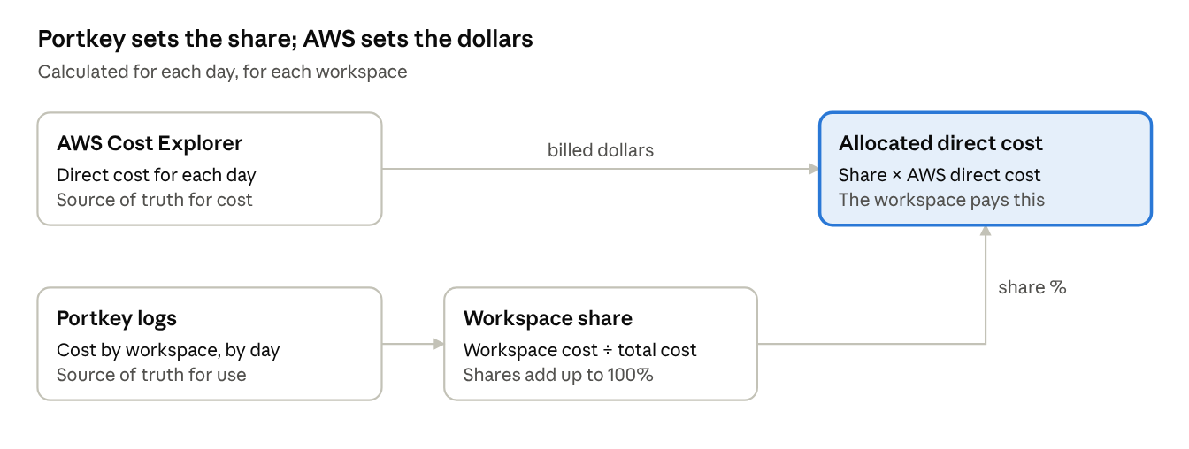
Direct cost allocation · 2 inputs, 1 share, 1 result
\begin{aligned}
\text{Workspace share} &= \frac{\text{Workspace Portkey cost for the day}}{\text{Total Portkey cost for the day}} \\
\text{Allocated direct cost} &= \text{Workspace share} \times \text{AWS direct cost for the day}
\end{aligned}
Rules:
- Calculate the share for each day. Then add the daily amounts to get the month.
- Use the Portkey cost, not the token count. A token for a large model costs more than a token for a small model. The Portkey cost includes this difference, so the model choice does not change the method.
- The shares for one day must add up to 100%.
- Do not bill the Portkey cost. Portkey shows list prices. AWS shows the billed cost.
Example for one day:
Workspace | Portkey cost (USD) | Share | Allocated AWS direct cost (USD)
Claude-Code | 900 | 45% | 1,035
ai-accelerator-dev | 500 | 25% | 575
es-fbs-dev | 100 | 5% | 115
All other workspaces | 500 | 25% | 575
Total | 2,000 | 100% | 2,300
On this day, Portkey shows $2,000 and AWS bills $2,300. Claude-Code used 45% in Portkey. Claude-Code pays 45% of $2,300, which is $1,035.

4. Example: the chargeback for three workspaces
Claude-Code pays $44,100 for the example month. ai-accelerator-dev pays $24,500 and es-fbs-dev pays $4,900. Each workspace pays the same share of the shared cost as its share of the direct cost.
This example uses the month from section 2: direct cost $70,000, Shared Cost A $17,500 and Shared Cost B $10,500.
Workspace | Share of direct cost | Direct cost (USD) | Shared Cost A (USD) | Shared Cost B (USD) | Total chargeback (USD)
Claude-Code | 45% | 31,500 | 7,875 | 4,725 | 44,100
ai-accelerator-dev | 25% | 17,500 | 4,375 | 2,625 | 24,500
es-fbs-dev | 5% | 3,500 | 875 | 525 | 4,900
All other workspaces | 25% | 17,500 | 4,375 | 2,625 | 24,500
Total | 100% | 70,000 | 17,500 | 10,500 | 98,000
How to calculate one row:
- Get the direct cost for the workspace. This is the sum of its daily allocations from section 3.
- Get the share of direct cost: workspace direct cost ÷ total direct cost.
- Multiply Shared Cost A by the share. Multiply Shared Cost B by the share.
- Add the three amounts. This is the total chargeback.
Check: the Total row must equal the amounts from section 2. The chargeback adds up to $98,000. Nothing is added on top, and nothing is left over.

5. Estimate: use the load rate
For each $1.00 of inference, add $0.40 for shared cost. The 40% is the load rate from the example month. Use the load rate to estimate the cost of a new or growing workspace.
\begin{aligned}
\text{Load rate} &= \frac{\text{Shared Cost A} + \text{Shared Cost B}}{\text{Direct cost}} = \frac{17{,}500 + 10{,}500}{70{,}000} = 40\% \\
\text{Estimated total cost} &= \text{Estimated inference cost} \times (1 + \text{Load rate})
\end{aligned}
In the example month, Shared Cost A gives 25% and Shared Cost B gives 15%. Together they give the 40% load rate.
How to make an estimate:
- Estimate the inference cost for the workspace. Use the models, the number of requests and the tokens for each request. The AI cost estimator gives this number.
- Get the load rate from the chargeback data for the last 3 months.
- Multiply the inference cost by (1 + load rate).
- Show the inference cost and the load on separate lines. Then show the total.
The model choice changes step 1 only. The load rate is the same for all models.
Estimated inference (USD/month) | Load at 40% (USD/month) | Estimated total (USD/month)
1,000 | 400 | 1,400
3,000 | 1,200 | 4,200
10,000 | 4,000 | 14,000
Cautions:
- The shared cost does not grow with each request. When total inference goes up, the load rate goes down. Calculate the load rate again each month.
- Use an average of 3 months. One month can have a spike.
- Estimate the build phase (development) and the run phase separately. Apply the load rate to both.

6. Decision: DEV and PROD buckets
The recommendation is to pool DEV and PROD in one bucket now, and to split them later. The final decision is for the FinOps product owner and finance.
The PROD gateway runs all the time, but it has little inference today. Its infrastructure must still be recovered. The question is who pays for it.
Option | How it works | DEV load rate | PROD load rate | Recovers PROD infrastructure | Trade-off
1. One bucket | Pool all gateway infrastructure and all inference from DEV and PROD. | 40% | 40% | Yes | DEV users pay for PROD before they use it.
2. Separate buckets | Each environment pays for its own infrastructure. | 35% | 415% | Yes, but only from PROD users | The first teams in PROD pay a very high rate.
3. Pool now, split later (recommended) | Charge back as one bucket. Show DEV and PROD separately in showback. Split when PROD reaches an agreed share of inference. | 40% | 40% until the split | Yes | The team must agree on the trigger and track it.
The load rates use the example month from section 2. Option 2 gives Shared Cost B to each environment in proportion to its direct cost.
Why option 3:
- It recovers the PROD infrastructure from the first month.
- It keeps one simple rate for chargeback.
- Showback shows the PROD part. In the example month, about 6 points of the 40% load (5.7%) are PROD infrastructure.
- The rule to split is agreed before it is needed.
Proposed trigger (to confirm): split the buckets when PROD inference is more than 25% of total inference for 3 months in a row.
Fallback: the AI platform order number pays for the PROD infrastructure as a central cost. This does not recover the cost from users. Use it only if the other options are not approved.

Open items
Confirm these items before the Word document goes out.
- ☐ Which AWS services go into Shared Cost A (for example: compute, network, logs and storage for the Portkey install).
- ☐ The Shared Cost B amount from the foundation accounts. Is it a fixed 15%, or a calculated amount?
- ☐ The billing level: workspace, AppID or order number.
- ☐ Scope: DEV first, then PROD. AWS first, then Azure.
- ☐ The AWS cost type: net amortized cost, after discounts and credits.
- ☐ Where to put inference that does not go through Portkey (for example, a separate unallocated line).
- ☐ Replace the example lines with the real Cost Explorer lines from the gateway accounts (DEV first) and the foundation accounts.
- ☐ Confirm which Claude models are in use, and how the gateway runs (EKS, ECS or EC2).
- ☐ Confirm the foundation accounts (PGE-Master, PGE-LZSharedServices-Prod or others) and the AI part of each.
- ☐ Decide the DEV and PROD buckets, and the trigger to split them (section 6).

Sources
- Bedrock billing classification in Cost Explorer (Classmethod)
- Bedrock product attributes in Cost Explorer (Classmethod)
- AWS Bedrock pricing and billing (Economize)

